

**AI PROJECT**

### On

**Brain Tumour Image Segmentation Using**

**Deep Networks**

**DEPARTMENT OF COMPUTER SCIENCE AND ENGINEERING**

Submitted By

AMRUTA - 218R1A05D2

NAVYA - 218R1A05E9

N AKSHITH RAJ - 218R1A0567

KARUNA SRI - 218R1A0571



Under the guidance of

**MR.B.Mahender**

ASSISTANT PROFESSOR, CSE

**2023-2024**

**DEPARTMENT OF COMPUTER SCIENCE AND ENGINEERING**

**CMR ENGINEERING COLLEGE**

#### UGC AUTONOMOUS

( Approved by AICTE-New Delhi & J.N.T.U, Hyderabad ) Kandlakoya(v),Medchal Road, Hyderabad-501401, Telangana State,India.



## 

## CERTIFICATE

This is to certify that the project entitled "**Brain Tumour Image Segmentation"** is a work carried out by:

AMRUTA - 218R1A05D2

NAVYA - 218R1A05E9

N AKSHITH RAJ - 218R1A0567

KARUNA SRI - 218R1A0571

In the part of innovative teaching methodology **PBL (Project Based Learning)** of Artificial Intelligence under our guidance and supervision.

|  |  |
| --- | --- |
| Internal Guide  MR. b.mahender  Assistant Professor Department of CSE  CMREC, Hyderabad | Head of the Department  Dr. Sheo Kumar  Professor & HOD  Department of CSE  CMREC, Hyderabad |

**DECLARATION**

This is to certify that the work reported in the present PBL entitled “CYBER ATTACKS DETECTION” is a record of bonafide work done by us in the Department of Computer Science and Engineering, CMR Engineering College, JNTU Hyderabad. The reports are based on the project work done entirely by us and not copied from any other source. We submit our PBL for further development by any interested students who share similar interests to improve the pbl in the future. The results embodied in this pbl report have not been submitted to any other University or Institute for the award of any degree or diploma to the best of our knowledge and belief.

AMRUTA - 218R1A05D2

NAVYA - 218R1A05E9

N AKSHITH RAJ - 218R1A0567

KARUNA SRI - 218R1A0571

**ACKNOWLEDGEMENT**

We are extremely grateful to Dr. A. Srinivasula Reddy, Principal and Dr. Sheo Kumar, HOD, Department of CSE, CMR Engineering College for their constant support. We are extremely thankful to Mr. B.Mahender, Assistant Professor, Internal Guide, Department of CSE, for his constant guidance, encouragement and moral support throughout the project. We will be in duty if I do not acknowledge with grateful thanks to the authors of the references and other literatures referred in this PBL. We express my thanks to all staff members and friends for all the help and co-ordination extended in bringing out this PBL successfully in time. Finally, we are very much thankful to my parents who guided me for every step.

AMRUTA - 218R1A05D2

NAVYA - 218R1A05E9

N AKSHITH RAJ- 218R1A0567

KARUNA SRI- 218R1A0571

**ABSTRACT:**

Automated segmentation of brain tumour from multimodal MR images is pivotal for the analysis and monitoring of disease progression. As gliomas are malignant and heterogeneous, efficient and accurate segmentation techniques are used for the successful delineation of tumours into intra-tumoural classes. Deep learning algorithms outperform on tasks of semantic segmentation as opposed to the more conventional, context-based computer vision approaches. Extensively used for biomedical image segmentation, Convolutional Neural Networks have significantly improved the state-of-the-art accuracy on the task of brain tumour segmentation. In this paper, we propose an ensemble of two segmentation networks: a 3D CNN and a U-Net, in a significant yet straightforward combinative technique that results in better and accurate predictions. Both models were trained separately on the BraTS-19 challenge dataset and evaluated to yield segmentation maps which considerably differed from each other in terms of segmented tumour sub-regions and were ensembled variably to achieve the final prediction. The suggested ensemble achieved dice scores of 0.750, 0.906 and 0.846 for enhancing tumour, whole tumour, and tumour core, respectively, on the validation set, performing favourably in comparison to the state-of-the-art architectures currently available.

**SYSTEM ANALYSIS**

**EXISTING SYSTEM**

To automate brain tumour segmentation process author is combining both 3D CNN and UNET algorithms as deep learning is gaining popularity in efficient semantic segmentation of medical images. To further enhance segmentation process author is using combination or ensemble of two deep learning algorithms called CNN and UNET. Both algorithms trained separately on BRATS brain tumour dataset and then predicted output of both algorithms will be merge or map to generate final segmentation and the output generated is giving high dice score after mapping both algorithms segmentation and then predicting final segmented output. Dice score refers to correctly mapping of segmented parts in the image.The task is to develop an automated brain tumour segmentation method, for successful delineation of tumours into intra-tumoural classes with improved efficiency and accuracy in comparison to existing methods.

**Disadvantage:**

1.Less Accuracy.

**PROPOSED SYSTEM:**

To implement this project we are using 4 different images and this images are called as FLAIR, T1, T2 and T1CE and the label segmented image. The multi-institutional dataset, acquired from 19 different contributors, contains multimodal MRI scans of each patient, namely T1, T1 contrast-enhanced (T1ce), T2-weighted (T2), and Fluid Attenuated Inversion Recovery (FLAIR), from which the tumoural sub regions are segmented. The data is processed to overcome discrepancies such that they are skull-stripped.

**Advantage:**

1.More Accuracy.

**SYSTEM REQUIREMENTS:**

**HARDWARE REQUIREMENTS:**

# **Processor - Pentium –IV**

* Speed - 1.1 Ghz
* RAM - 256 MB(min)
* Hard Disk - 20 GB
* Key Board - Standard Windows Keyboard
* Mouse - Two or Three Button Mouse
* Monitor - SVGA

**SOFTWARE REQUIREMENTS:**

* Operating System - Windows7/8\
* Programming Language - Python

Table of Contents

**1.Introduction** **1**

1.1 Objective 2

**2.Literature Survey** **3**

**3.System Analysis6**

3.1 Existing System6

3.2 Proposed System6

3.3 Process Model with justification11

3.4 Software Requirement Specification18

3.4.1 Overall Description18

3.4.2 External Interface Requirements19

**4.System Design20**

**5.Implementation29**

5.1 Python29

5.2 Sample Code32

**6.Testing34**

**7.Output45**

**8.Conclusion46**

* **9.References46**

**1. INTRODUCTION:**

Accurate segmentation of tumours through medical images is of particular importance as it provides information essential for analysis and diagnosis of cancer as well as for mapping out treatment options and monitoring the progression of the disease. Brain tumours are one of the fatal cancers worldwide and are categorised, depending upon their origin, into primary and secondary tumour types. The most common histological form of primary brain cancer is the glioma, which originates from the brain glial cells and attributes towards 80% of all malignant brain tumours. Gliomas can be of the slow-progressing low-grade (LGG) subtype with a better patient prognosis or are the more aggressive and infiltrative high-grade glioma (HGG) or glioblastoma, which require immediate treatment. These tumours are associated with substantial morbidity, where the median survival for a patient with glioblastoma is only about 14 months with a 5-year survival rate near zero despite maximal surgical and medical therapy. A timely diagnosis, therefore, becomes imperative for effective treatment of the patients. Magnetic Resonance Imaging (MRI) is a preferred technique widely employed by radiologists for the evaluation and assessment of brain tumours . It provides several complimentary 3D MRI modalities acquired based on the degree of excitation and repetition times, i.e. T1-weighted, post-contrast T1-weighted (T1ce), T2-weighted and Fluid-Attenuated Inversion Recovery (FLAIR). The highlighted subregions of the tumour across different intensities of these sequences, such as the whole tumour (the entire tumour inclusive of infiltrative oedema), is more prominent in FLAIR and T2 modalities. In contrast, T1 and T1ce images show the tumour core exclusive of peritumoural oedema. It allows for the combinative use of these scans and the complementary information they deliver towards the detection of different tumour subregions. The Multimodal Brain Tumour Segmentation Challenge (BraTS) is a platform to evaluate the development of machine learning models for the task of tumour segmentation, by facilitating the participants with an extensive dataset of 3D MRI images of the gliomas (both LGG and HGG) and associated ground truths annotated by expert physicians. The provided multimodal scans are used for both training and validating the neural networks designed for the particular segmentation task. Manually delineating brain tumour subregions from MRI scans is a subjective task, and therefore it is time-consuming and prone to variability. Automated segmentation of gliomas from multimodal MRI images can consequently assist the physicians to speed-up diagnosis and surgical planning as well as provide an accurate, reproducible solution for further tumour analysis and monitoring . The classical methods of automated brain tumour segmentation rely on feature engineering, which involves the extraction of handcrafted features from input images with follow up training of classifier. Unsupervised learning algorithms bypass the complexity in designing and selecting features by automatically learning a hierarchy of feature representation, with deep learning models excelling at the task . Convolutional Neural Networks (CNNs) is regarded as the state of the art methods for brain tumour image segmentation as they learn the most useful and relevant features automatically . However, accurate segmentation of tumour remains a challenge; due to heterogeneity in terms of shape, size, and appearance of the gliomas as well as ambiguous and fuzzy boundary existing between cancer and brain tissue. The intensity variability of the MRI data further adds to this difficulty. Therefore, it is still open to improvement, allowing further exploration for better segmentation techniques and accuracy. In this work, we utilise multiple 3D CNN models for brain tumour segmentation from multimodal MRI scans and ensemble their probability maps for more stable predictions. The networks are trained separately, with hyperparameters optimised for each model, on the training dataset acquired from the 2019 Brain Tumour Segmentation (BraTS) challenge. A rigorous evaluation on the BraTS validation set resulted with the proposed ensemble achieving dice scores of 0.750, 0.906 and 0.846 for enhancing tumour, whole tumour, and tumour core, respectively.

**1.1.Objective of the project:**

Automated segmentation of brain tumour from multimodal MR images is pivotal for the analysis and monitoring of disease progression. As gliomas are malignant and heterogeneous, efficient and accurate segmentation techniques are used for the successful delineation of tumours into intra-tumoural classes. Deep learning algorithms outperform on tasks of semantic segmentation as opposed to the more conventional, context-based computer vision approaches. Extensively used for biomedical image segmentation, Convolutional Neural Networks have significantly improved the state-of-the-art accuracy on the task of brain tumour segmentation. In this paper, we propose an ensemble of two segmentation networks: a 3D CNN and a U-Net, in a significant yet straightforward combinative technique that results in better and accurate predictions. Both models were trained separately on the BraTS-19 challenge dataset and evaluated to yield segmentation maps which considerably differed from each other in terms of segmented tumour sub-regions and were ensembled variably to achieve the final prediction. The suggested ensemble achieved dice scores of 0.750, 0.906 and 0.846 for enhancing tumour, whole tumour, and tumour core, respectively, on the validation set, performing favourably in comparison to the state-of-the-art architectures currently available.

**2. LITERATURE SERVEY:**

**A survey of MRI-based medical image analysis for brain tumour studies**

MRI-based medical image analysis for brain tumor studies is gaining attention in recent times due to an increased need for efficient and objective evaluation of large amounts of data. While the pioneering approaches applying automated methods for the analysis of brain tumor images date back almost two decades, the current methods are becoming more mature and coming closer to routine clinical application. This review aims to provide a comprehensive overview by giving a brief introduction to brain tumors and imaging of brain tumors first. Then, we review the state of the art in segmentation, registration and modeling related to tumor-bearing brain images with a focus on gliomas. The objective in the segmentation is outlining the tumor including its sub-compartments and surrounding tissues, while the main challenge in registration and modeling is the handling of morphological changes caused by the tumor. The qualities of different approaches are discussed with a focus on methods that can be applied on standard clinical imaging protocols. Finally, a critical assessment of the current state is performed and future developments and trends are addressed, giving special attention to recent developments in radiological tumor assessment guidelines.

**Global incidence of malignant brain and other central nervous system tumours by histology, 2003--2007**

Previous reports have shown that overall incidence of malignant brain and other central nervous system (CNS) tumors varied significantly by country. The aim of this study was to estimate histology-specific incidence rates by global region and assess incidence variation by histology and age. Using data from the Central Brain Tumor Registry of the United States (CBTRUS) and the International Agency for Research on Cancer’s (IARC) Cancer Incidence in Five Continents X (including over 300 cancer registries), we calculated the age-adjusted incidence rates (AAIR) per 100000 person-years and 95% CIs for brain and other CNS tumors overall and by age groups and histology. Brain and other CNS tumors are a significant source of cancer-related morbidity and mortality worldwide. Regional differences in incidence may provide clues toward genetic or environmental causes as well as a foundation for broadening knowledge of their epidemiology. Gaining a comprehensive understanding of the epidemiology of malignant brain tumors globally is critical to researchers, public health officials, disease interest groups, and clinicians and contributes to collaborative efforts in future research**.**

**CBTRUS statistical report: primary brain and central nervous system tumours diagnosed in the United States in 2005--2009**

The Central Brain Tumor Registry of the United States (CBTRUS), in collaboration with the Centers for Disease Control (CDC) and National Cancer Institute (NCI), is the largest population-based registry focused exclusively on primary brain and other central nervous system (CNS) tumors in the United States (US) and represents the entire US population. This report contains the most up-to-date population-based data on primary brain tumors (malignant and non-malignant) and supersedes all previous CBTRUS reports in terms of completeness and accuracy. All rates (incidence and mortality) are age-adjusted using the 2000 US standard population and presented per 100,000 population. The average annual age-adjusted incidence rate (AAAIR) of all malignant and non-malignant brain and other CNS tumors was 23.79 (Malignant AAAIR=7.08, non-Malignant AAAIR=16.71). This rate was higher in females compared to males (26.31 versus 21.09), Blacks compared to Whites (23.88 versus 23.83), and non-Hispanics compared to Hispanics (24.23 versus 21.48). The most commonly occurring malignant brain and other CNS tumor was glioblastoma (14.5% of all tumors), and the most common non-malignant tumor was meningioma (38.3% of all tumors). Glioblastoma was more common in males, and meningioma was more common in females. In children and adolescents (age 0-19 years), the incidence rate of all primary brain and other CNS tumors was 6.14. An estimated 83,830 new cases of malignant and non-malignant brain and other CNS tumors are expected to be diagnosed in the US in 2020 (24,970 malignant and 58,860 non-malignant). There were 81,246 deaths attributed to malignant brain and other CNS tumors between 2013 and 2017. This represents an average annual mortality rate of 4.42. The 5-year relative survival rate following diagnosis of a malignant brain and other CNS tumor was 36.0% and for a non-malignant brain and other CNS tumor was 91.7%.

**The 2016 World Health rganization classification of tumours of the central nervous system**

The 2016 World Health Organization Classification of Tumors of the Central Nervous System is both a conceptual and practical advance over its 2007 predecessor. For the first time, the WHO classification of CNS tumors uses molecular parameters in addition to histology to define many tumor entities, thus formulating a concept for how CNS tumor diagnoses should be structured in the molecular era. As such, the 2016 CNS WHO presents major restructuring of the diffuse gliomas, medulloblastomas and other embryonal tumors, and incorporates new entities that are defined by both histology and molecular features, including glioblastoma, IDH-wildtype and glioblastoma, IDH-mutant; diffuse midline glioma, H3 K27M-mutant; RELA fusion-positive ependymoma; medulloblastoma, WNT-activated and medulloblastoma, SHH-activated; and embryonal tumour with multilayered rosettes, C19MC-altered. The 2016 edition has added newly recognized neoplasms, and has deleted some entities, variants and patterns that no longer have diagnostic and/or biological relevance. Other notable changes include the addition of brain invasion as a criterion for atypical meningioma and the introduction of a soft tissue-type grading system for the now combined entity of solitary fibrous tumor / hemangiopericytoma-a departure from the manner by which other CNS tumors are graded. Overall, it is hoped that the 2016 CNS WHO will facilitate clinical, experimental and epidemiological studies that will lead to improvements in the lives of patients with brain tumors.

**Radiotherapy plus concomitant and adjuvant temozolomide for glioblastoma**

Glioblastoma, the most common primary brain tumor in adults, is usually rapidly fatal. The current standard of care for newly diagnosed glioblastoma is surgical resection to the extent feasible, followed by adjuvant radiotherapy. In this trial we compared radiotherapy alone with radiotherapy plus temozolomide, given concomitantly with and after radiotherapy, in terms of efficacy and safety.Patients with newly diagnosed, histologically confirmed glioblastoma were randomly assigned to receive radiotherapy alone (fractionated focal irradiation in daily fractions of 2 Gy given 5 days per week for 6 weeks, for a total of 60 Gy) or radiotherapy plus continuous daily temozolomide (75 mg per square meter of body-surface area per day, 7 days per week from the first to the last day of radiotherapy), followed by six cycles of adjuvant temozolomide (150 to 200 mg per square meter for 5 days during each 28-day cycle). The primary end point was overall survival.A total of 573 patients from 85 centers underwent randomization. The median age was 56 years, and 84 percent of patients had undergone debulking surgery. At a median follow-up of 28 months, the median survival was 14.6 months with radiotherapy plus temozolomide and 12.1 months with radiotherapy alone. The unadjusted hazard ratio for death in the radiotherapy-plus-temozolomide group was 0.63 (95 percent confidence interval, 0.52 to 0.75; P<0.001 by the log-rank test). The two-year survival rate was 26.5 percent with radiotherapy plus temozolomide and 10.4 percent with radiotherapy alone. Concomitant treatment with radiotherapy plus temozolomide resulted in grade 3 or 4 hematologic toxic effects in 7 percent of patients.The addition of temozolomide to radiotherapy for newly diagnosed glioblastoma resulted in a clinically meaningful and statistically significant survival benefit with minimal additional toxicity.

**3. SYSTEM ANALYSIS**

**3.1 Existing System**

To automate brain tumour segmentation process author is combining both 3D CNN and UNET algorithms as deep learning is gaining popularity in efficient semantic segmentation of medical images. To further enhance segmentation process author is using combination or ensemble of two deep learning algorithms called CNN and UNET. Both algorithms trained separately on BRATS brain tumour dataset and then predicted output of both algorithms will be merge or map to generate final segmentation and the output generated is giving high dice score after mapping both algorithms segmentation and then predicting final segmented output. Dice score refers to correctly mapping of segmented parts in the image.The task is to develop an automated brain tumour segmentation method, for successful delineation of tumours into intra-tumoural classes with improved efficiency and accuracy in comparison to existing methods.

**Disadvantage:**

1.Less Accuracy.

**3.2. Proposed System:**

To implement this project we are using 4 different images and this images are called as FLAIR, T1, T2 and T1CE and the label segmented image. The multi-institutional dataset, acquired from 19 different contributors, contains multimodal MRI scans of each patient, namely T1, T1 contrast-enhanced (T1ce), T2-weighted (T2), and Fluid Attenuated Inversion Recovery (FLAIR), from which the tumoural sub regions are segmented. The data is processed to overcome discrepancies such that they are skull-stripped.

**Advantage:**

1.More Accuracy.

**Modules:**

1.upload BRATS Dataset

2.Generate CNN & UNET Model

3.Upload Test Image & Segmentation

4.Dice Similarity Graph

**1.upload BRATS Dataset:**

upload BRATS Dataset is the first module of our project,it is used to upload the BRATS dataset.

**2.Generate CNN & UNET Model:**

Generate CNN & UNET Model is the second module of our project,it is used to models are generated and console to see CNN and UNET layer details. we can see models are using different size images to filter them and to get best features from it to build efficient model and now model is generated.

**3.Upload Test Image & Segmentation:**

Upload Test Image & Segmentation is the third module of our project and then upload test samples to get segmented output. selecting and uploading ‘Sample1’ folder and then click on ‘Select Folder’ button to get below outputtop 4 images are the input images such as FLAIR, T1, T2 and T1CE and 5th image is the predicted image with segmented part showing in red colour and this algorithm correctly detecting and marking tumour area and now test with other image.

**4.Dice Similarity Graph:**

To build CNN and UNET model we took 50 epoch or iterations and at each iteration DICE score between training and testing images get better and better and we get final dice score as 0.8 * 100 = 80%. In above graph x-axis represents epoch and y-axis represents dice score.

**3.3. PROCESS MODEL USED WITH JUSTIFICATION**

**SDLC (Umbrella Model):**

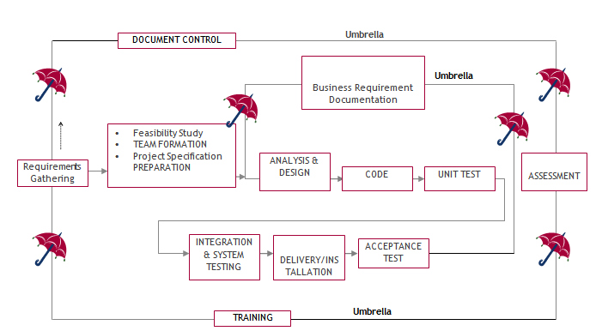

The requirements gathering process takes as its input SDLC is nothing but Software Development Life Cycle. It is a standard which is used by software industry to develop good software.

**Stages in SDLC:**

* Requirement Gathering
* Analysis
* Designing
* Coding
* Testing
* Maintenance

**Requirements Gathering** **stage:**

the goals identified in the high-level requirements section of the project plan. Each goal will be refined into a set of one or more requirements. These requirements define the major functions of the intended application, define operational data areas and reference data areas, and define the initial data entities. Major functions include critical processes to be managed, as well as mission critical inputs, outputs and reports. A user class hierarchy is developed and associated with these major functions, data areas, and data entities. Each of these definitions is termed a Requirement. Requirements are identified by unique requirement identifiers and, at minimum, contain a requirement title and textual description.

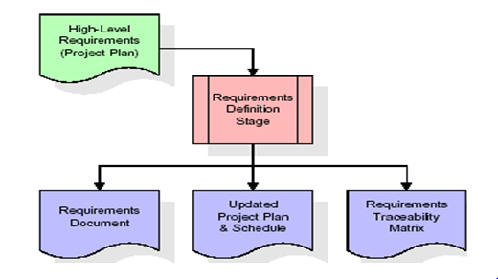

These requirements are fully described in the primary deliverables for this stage: the Requirements Document and the Requirements Traceability Matrix (RTM). The requirements document contains complete descriptions of each requirement, including diagrams and references to external documents as necessary. Note that detailed listings of database tables and fields are *not* included in the requirements document.

The title of each requirement is also placed into the first version of the RTM, along with the title of each goal from the project plan. The purpose of the RTM is to show that the product components developed during each stage of the software development lifecycle are formally connected to the components developed in prior stages.

In the requirements stage, the RTM consists of a list of high-level requirements, or goals, by title, with a listing of associated requirements for each goal, listed by requirement title. In this hierarchical listing, the RTM shows that each requirement developed during this stage is formally linked to a specific product goal. In this format, each requirement can be traced to a specific product goal, hence the term requirements traceability.

The outputs of the requirements definition stage include the requirements document, the RTM, and an updated project plan.

* Feasibility study is all about identification of problems in a project.
* No. of staff required to handle a project is represented as Team Formation, in this case only modules are individual tasks will be assigned to employees who are working for that project.
* Project Specifications are all about representing of various possible inputs submitting to the server and corresponding outputs along with reports maintained by administrator.

**Analysis Stage:**

The planning stage establishes a bird's eye view of the intended software product, and uses this to establish the basic project structure, evaluate feasibility and risks associated with the project, and describe appropriate management and technical approaches.

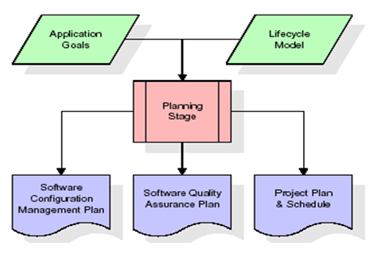

The most critical section of the project plan is a listing of high-level product requirements, also referred to as goals. All of the software product requirements to be developed during the requirements definition stage flow from one or more of these goals. The minimum information for each goal consists of a title and textual description, although additional information and references to external documents may be included. The outputs of the project planning stage are the configuration management plan, the quality assurance plan, and the project plan and schedule, with a detailed listing of scheduled activities for the upcoming Requirements stage, and high level estimates of effort for the out stages.

**Designing Stage:**

The design stage takes as its initial input the requirements identified in the approved requirements document. For each requirement, a set of one or more design elements will be produced as a result of interviews, workshops, and/or prototype efforts. Design elements describe the desired software features in detail, and generally include functional hierarchy diagrams, screen layout diagrams, tables of business rules, business process diagrams, pseudo code, and a complete entity-relationship diagram with a full data dictionary. These design elements are intended to describe the software in sufficient detail that skilled programmers may develop the software with minimal additional input.

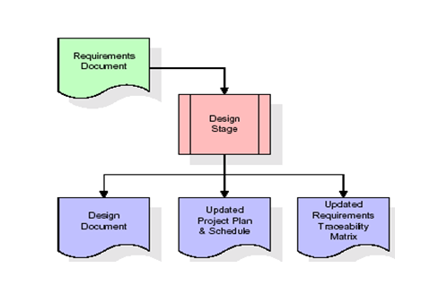

When the design document is finalized and accepted, the RTM is updated to show that each design element is formally associated with a specific requirement. The outputs of the design stage are the design document, an updated RTM, and an updated project plan.

**Development (Coding) Stage:**

The development stage takes as its primary input the design elements described in the approved design document. For each design element, a set of one or more software artifacts will be produced. Software artifacts include but are not limited to menus, dialogs, and data management forms, data reporting formats, and specialized procedures and functions. Appropriate test cases will be developed for each set of functionally related software artifacts, and an online help system will be developed to guide users in their interactions with the software.

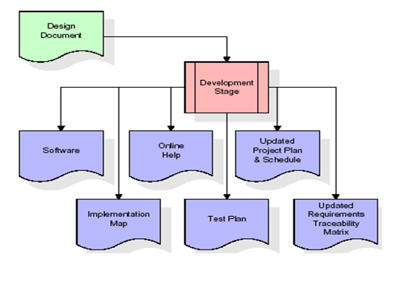

The RTM will be updated to show that each developed artifact is linked to a specific design element, and that each developed artifact has one or more corresponding test case items. At this point, the RTM is in its final configuration. The outputs of the development stage include a fully functional set of software that satisfies the requirements and design elements previously documented, an online help system that describes the operation of the software, an implementation map that identifies the primary code entry points for all major system functions, a test plan that describes the test cases to be used to validate the correctness and completeness of the software, an updated RTM, and an updated project plan.

**Integration & Test Stage:**

During the integration and test stage, the software artifacts, online help, and test data are migrated from the development environment to a separate test environment. At this point, all test cases are run to verify the correctness and completeness of the software. Successful execution of the test suite confirms a robust and complete migration capability. During this stage, reference data is finalized for production use and production users are identified and linked to their appropriate roles. The final reference data (or links to reference data source files) and production user list are compiled into the Production Initiation Plan.

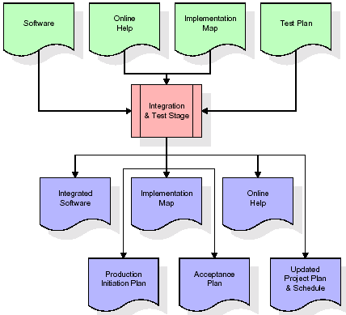

The outputs of the integration and test stage include an integrated set of software, an online help system, an implementation map, a production initiation plan that describes reference data and production users, an acceptance plan which contains the final suite of test cases, and an updated project plan.

* **Installation & Acceptance Test:**

During the installation and acceptance stage, the software artifacts, online help, and initial production data are loaded onto the production server. At this point, all test cases are run to verify the correctness and completeness of the software. Successful execution of the test suite is a prerequisite to acceptance of the software by the customer.

After customer personnel have verified that the initial production data load is correct and the test suite has been executed with satisfactory results, the customer formally accepts the delivery of the software.

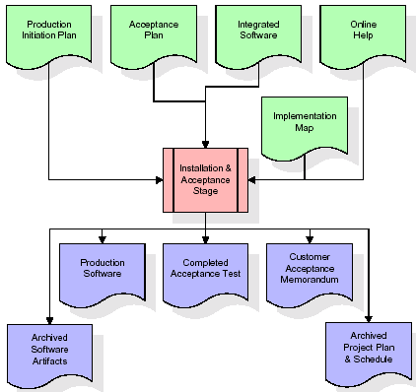

The primary outputs of the installation and acceptance stage include a production application, a completed acceptance test suite, and a memorandum of customer acceptance of the software. Finally, the PDR enters the last of the actual labor data into the project schedule and locks the project as a permanent project record. At this point the PDR "locks" the project by archiving all software items, the implementation map, the source code, and the documentation for future reference.

**Maintenance:**

Outer rectangle represents maintenance of a project, Maintenance team will start with requirement study, understanding of documentation later employees will be assigned work and they will undergo training on that particular assigned category. For this life cycle there is no end, it will be continued so on like an umbrella (no ending point to umbrella sticks).

**3.4. Software Requirement Specification**

**3.4.1. Overall Description**

A Software Requirements Specification (SRS) – a [requirements specification](http://en.wikipedia.org/wiki/Requirements_specification) for a [software system](http://en.wikipedia.org/wiki/Software_system) is a complete description of the behavior of a system to be developed. It includes a set of [use cases](http://en.wikipedia.org/wiki/Use_case) that describe all the interactions the users will have with the software. In addition to use cases, the SRS also contains non-functional requirements. [Nonfunctional requirements](http://en.wikipedia.org/wiki/Non-functional_requirements) are requirements which impose constraints on the design or implementation (such as [performance engineering](http://en.wikipedia.org/wiki/Performance_engineering) requirements, [quality](http://en.wikipedia.org/wiki/Quality_%28business%29) standards, or design constraints).

System requirements specification: A structured collection of information that embodies the requirements of a system. A [business analyst](http://en.wikipedia.org/wiki/Business_analyst), sometimes titled [system analyst](http://en.wikipedia.org/wiki/System_analyst), is responsible for analyzing the business needs of their clients and stakeholders to help identify business problems and propose solutions. Within the [systems development lifecycle](http://en.wikipedia.org/wiki/Systems_development_life_cycle) domain, the BA typically performs a liaison function between the business side of an enterprise and the information technology department or external service providers. Projects are subject to three sorts of requirements:

* [Business requirements](http://en.wikipedia.org/wiki/Business_requirements) describe in business terms *what* must be delivered or accomplished to provide value.
* Product requirements describe properties of a system or product (which could be one of several ways to accomplish a set of business requirements.)
* Process requirements describe activities performed by the developing organization. For instance, process requirements could specify .Preliminary investigation examine project feasibility, the likelihood the system will be useful to the organization. The main objective of the feasibility study is to test the Technical, Operational and Economical feasibility for adding new modules and debugging old running system. All system is feasible if they are unlimited resources and infinite time. There are aspects in the feasibility study portion of the preliminary investigation:
* **ECONOMIC FEASIBILITY**

A system can be developed technically and that will be used if installed must still be a good investment for the organization. In the economical feasibility, the development cost in creating the system is evaluated against the ultimate benefit derived from the new systems. Financial benefits must equal or exceed the costs. The system is economically feasible. It does not require any addition hardware or software. Since the interface for this system is developed using the existing resources and technologies available at NIC, There is nominal expenditure and economical feasibility for certain.

* **Operational Feasibility**

Proposed projects are beneficial only if they can be turned out into information system. That will meet the organization’s operating requirements. Operational feasibility aspects of the project are to be taken as an important part of the project implementation. This system is targeted to be in accordance with the above-mentioned issues. Beforehand, the management issues and user requirements have been taken into consideration. So there is no question of resistance from the users that can undermine the possible application benefits. The well-planned design would

ensure the optimal utilization of the computer resources and would help in the improvement of performance status.

* **TECHNICAL FEASIBILITY**

Earlier no system existed to cater to the needs of ‘Secure Infrastructure Implementation System’. The current system developed is technically feasible. It is a web based user interface for audit workflow at NIC-CSD. Thus it provides an easy access to .the users. The database’s purpose is to create, establish and maintain a workflow among various entities in order to facilitate all concerned users in their various capacities or roles. Permission to the users would be granted based on the roles specified. Therefore, it provides the technical guarantee of accuracy, reliability and security.

**4. SYSTEM DESIGN**

**UML Diagram:**

**Class Diagram:**

The class diagram is the main building block of object oriented modeling. It is used both for general conceptual modeling of the systematic of the application, and for detailed modeling translating the models into programming code. Class diagrams can also be used for data modeling. The classes in a class diagram represent both the main objects, interactions in the application and the classes to be programmed. In the diagram, classes are represented with boxes which contain three parts:

* The upper part holds the name of the class
* The middle part contains the attributes of the class
* The bottom part gives the methods or operations the class can take or undertake.

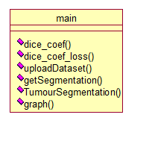

**Use case Diagram:**

A use case diagram at its simplest is a representation of a user's interaction with the system and depicting the specifications of a use case. A use case diagram can portray the different types of users of a system and the various ways that they interact with the system. This type of diagram is typically used in conjunction with the textual use case and will often be accompanied by other types of diagrams as well.

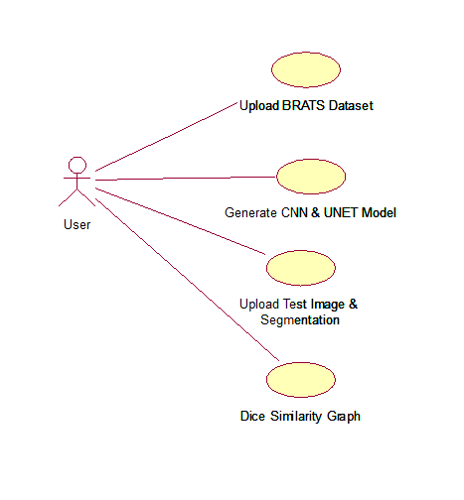

**Sequence Diagram:**

A sequence diagram is a kind of interaction diagram that shows how processes operate with one another and in what order. It is a construct of a Message Sequence Chart. A sequence diagram shows object interactions arranged in time sequence. It depicts the objects and classes involved in the scenario and the sequence of messages exchanged between the objects needed to carry out the functionality of the scenario. Sequence diagrams are typically associated with use case realizations in the Logical View of the system under development. Sequence diagrams are sometimes called event diagrams, event scenarios, and timing diagrams.

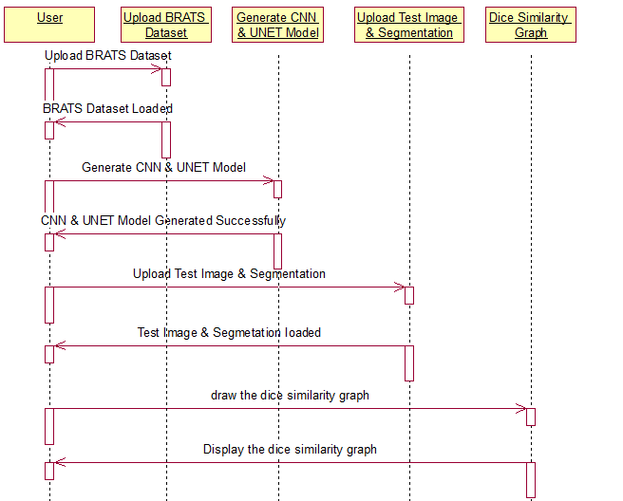

**Component Diagram:**

In the Unified Modeling Language, a component diagram depicts how components are wired together to form larger components and or software systems. They are used to illustrate the structure of arbitrarily complex systems.

Components are wired together by using an assembly connector to connect the required interface of one component with the provided interface of another component. This illustrates the service consumer - service provider relationship between the two components.

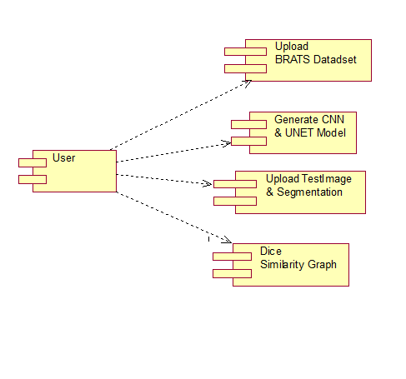

**Deployment Diagram:**

A deployment diagram in the Unified Modeling Language models the *physical* deployment of artifacts on nodes. To describe a web site, for example, a deployment diagram would show what hardware components ("nodes") exist (e.g., a web server, an application server, and a database server), what software components ("artifacts") run on each node (e.g., web application, database), and how the different pieces are connected (e.g. JDBC, REST, RMI).

The nodes appear as boxes, and the artifacts allocated to each node appear as rectangles within the boxes. Nodes may have sub nodes, which appear as nested boxes. A single node in a deployment diagram may conceptually represent multiple physical nodes, such as a cluster of database servers.

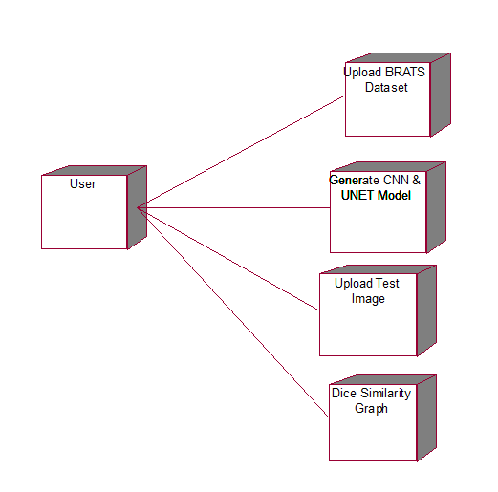

**Activity Diagram:**

Activity diagram is another important diagram in UML to describe dynamic aspects of the system. It is basically a flow chart to represent the flow form one activity to another activity. The activity can be described as an operation of the system. So the control flow is drawn from one operation to another. This flow can be sequential, branched or concurrent.

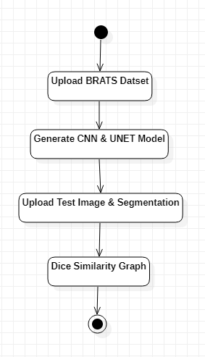

**Data Flow Diagram:**

Data flow diagrams illustrate how data is processed by a system in terms of inputs and outputs. Data flow diagrams can be used to provide a clear representation of any business function. The technique starts with an overall picture of the business and continues by analyzing each of the functional areas of interest. This analysis can be carried out in precisely the level of detail required. The technique exploits a method called top-down expansion to conduct the analysis in a targeted way.

As the name suggests, Data Flow Diagram (DFD) is an illustration that explicates the passage of information in a process. A DFD can be easily drawn using simple symbols. Additionally, complicated processes can be easily automated by creating DFDs using easy-to-use, free downloadable diagramming tools. A DFD is a model for constructing and analyzing information processes. DFD illustrates the flow of information in a process depending upon the inputs and outputs. A DFD can also be referred to as a Process Model. A DFD demonstrates business or technical process with the support of the outside data saved, plus the data flowing from the process to another and the end results.

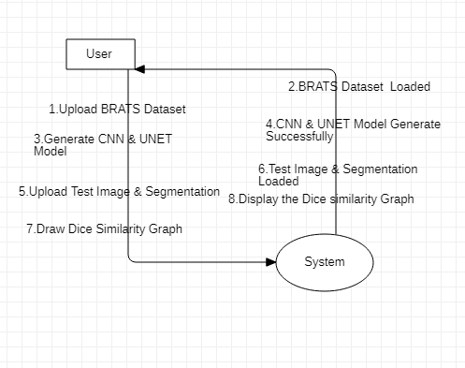

**5. IMPLEMETATION:**

**5.1 Python**

Python is a general-purpose language. It has wide range of applications from Web development (like: Django and Bottle), scientific and mathematical computing (Orange, SymPy, NumPy) to desktop graphical user Interfaces (Pygame, Panda3D). The syntax of the language is clean and length of the code is relatively short. It's fun to work in Python because it allows you to think about the problem rather than focusing on the syntax.

**History of Python:**

Python is a fairly old language created by Guido Van Rossum. The design began in the late 1980s and was first released in February 1991.

**Why Python was created?**

In late 1980s, Guido Van Rossum was working on the Amoeba distributed operating system group. He wanted to use an interpreted language like ABC (ABC has simple easy-to-understand syntax) that could access the Amoeba system calls. So, he decided to create a language that was extensible. This led to design of a new language which was later named Python.

**Why the name Python?**

No. It wasn't named after a dangerous snake. Rossum was fan of a comedy series from late seventies. The name "Python" was adopted from the same series "Monty Python's Flying Circus".

**Features of Python:**

**A simple language which is easier to learn**

Python has a very simple and elegant syntax. It's much easier to read and write Python programs compared to other languages like: C++, Java, C#. Python makes programming fun and allows you to focus on the solution rather than syntax.

If you are a newbie, it's a great choice to start your journey with Python.

**Free and open-source**

You can freely use and distribute Python, even for commercial use. Not only can you use and distribute softwares written in it, you can even make changes to the Python's source code.

Python has a large community constantly improving it in each iteration.

**Portability**

You can move Python programs from one platform to another, and run it without any changes.

It runs seamlessly on almost all platforms including Windows, Mac OS X and Linux.

**Extensible and Embeddable**

Suppose an application requires high performance. You can easily combine pieces of C/C++ or other languages with Python code.

This will give your application high performance as well as scripting capabilities which other languages may not provide out of the box.

**A high-level, interpreted language**

Unlike C/C++, you don't have to worry about daunting tasks like memory management, garbage collection and so on.

Likewise, when you run Python code, it automatically converts your code to the language your computer understands. You don't need to worry about any lower-level operations.

**Large standard libraries to solve common tasks**

Python has a number of standard libraries which makes life of a programmer much easier since you don't have to write all the code yourself. For example: Need to connect MySQL database on a Web server? You can use MySQLdb library using import MySQLdb .

Standard libraries in Python are well tested and used by hundreds of people. So you can be sure that it won't break your application.

**Object-oriented**

Everything in Python is an object. Object oriented programming (OOP) helps you solve a complex problem intuitively.

With OOP, you are able to divide these complex problems into smaller sets by creating objects.

**Applications of Python:**

**1. Simple Elegant Syntax**

Programming in Python is fun. It's easier to understand and write Python code. Why? The syntax feels natural. Take this source code for an example:

a = 2

b = 3

sum = a + b

print(sum)

**2. Not overly strict**

You don't need to define the type of a variable in Python. Also, it's not necessary to add semicolon at the end of the statement.

Python enforces you to follow good practices (like proper indentation). These small things can make learning much easier for beginners.

**3. Expressiveness of the language**

Python allows you to write programs having greater functionality with fewer lines of code. Here's a link to the source code of Tic-tac-toe game with a graphical interface and a smart computer opponent in less than 500 lines of code. This is just an example. You will be amazed how much you can do with Python once you learn the basics.

**4. Great Community and Support**

Python has a large supporting community. There are numerous active forums online which can be handy if you are stuck.

**5.2 Sample Code:**

from tkinter import messagebox

from tkinter import *

from tkinter import simpledialog

import tkinter

from tkinter import simpledialog

from tkinter import filedialog

import numpy as np

from tkinter.filedialog import askopenfilename

import pickle

import os

import cv2

import matplotlib.pyplot as plt

from sklearn.model_selection import train_test_split

from keras.models import *

from keras.layers import *

from keras.optimizers import *

gui = tkinter.Tk()

gui.title("Brain Tumour Image Segmentation Using Deep Networks")

gui.geometry("1300x1200")

global filename

global model

global X, Y

def dice_coef(y_true, y_pred):

y_true_f = keras.flatten(y_true)

y_pred_f = keras.flatten(y_pred)

intersection = keras.sum(y_true_f * y_pred_f)

return (2. * intersection + 1) / (keras.sum(y_true_f) + keras.sum(y_pred_f) + 1)

def dice_coef_loss(y_true, y_pred):

return -dice_coef(y_true, y_pred)

def getModel(input_size=(64,64,1)):

inputs = Input(input_size)

conv1 = Conv2D(32, (3, 3), activation='relu', padding='same')(inputs)

conv1 = Conv2D(32, (3, 3), activation='relu', padding='same')(conv1)

pool1 = MaxPooling2D(pool_size=(2, 2))(conv1)

conv2 = Conv2D(64, (3, 3), activation='relu', padding='same')(pool1)

conv2 = Conv2D(64, (3, 3), activation='relu', padding='same')(conv2)

pool2 = MaxPooling2D(pool_size=(2, 2))(conv2)

conv3 = Conv2D(128, (3, 3), activation='relu', padding='same')(pool2)

conv3 = Conv2D(128, (3, 3), activation='relu', padding='same')(conv3)

pool3 = MaxPooling2D(pool_size=(2, 2))(conv3)

conv4 = Conv2D(256, (3, 3), activation='relu', padding='same')(pool3)

conv4 = Conv2D(256, (3, 3), activation='relu', padding='same')(conv4)

pool4 = MaxPooling2D(pool_size=(2, 2))(conv4)

conv5 = Conv2D(512, (3, 3), activation='relu', padding='same')(pool4)

conv5 = Conv2D(512, (3, 3), activation='relu', padding='same')(conv5)

up6 = concatenate([Conv2DTranspose(256, (2, 2), strides=(2, 2), padding='same')(conv5), conv4], axis=3)

conv6 = Conv2D(256, (3, 3), activation='relu', padding='same')(up6)

conv6 = Conv2D(256, (3, 3), activation='relu', padding='same')(conv6)

up7 = concatenate([Conv2DTranspose(128, (2, 2), strides=(2, 2), padding='same')(conv6), conv3], axis=3)

conv7 = Conv2D(128, (3, 3), activation='relu', padding='same')(up7)

conv7 = Conv2D(128, (3, 3), activation='relu', padding='same')(conv7)

up8 = concatenate([Conv2DTranspose(64, (2, 2), strides=(2, 2), padding='same')(conv7), conv2], axis=3)

conv8 = Conv2D(64, (3, 3), activation='relu', padding='same')(up8)

conv8 = Conv2D(64, (3, 3), activation='relu', padding='same')(conv8)

up9 = concatenate([Conv2DTranspose(32, (2, 2), strides=(2, 2), padding='same')(conv8), conv1], axis=3)

conv9 = Conv2D(32, (3, 3), activation='relu', padding='same')(up9)

conv9 = Conv2D(32, (3, 3), activation='relu', padding='same')(conv9)

conv10 = Conv2D(1, (1, 1), activation='sigmoid')(conv9)

return Model(inputs=[inputs], outputs=[conv10])

def uploadDataset():

global X, Y

global filename

text.delete('1.0', END)

filename = filedialog.askdirectory(initialdir=".")

text.insert(END,filename+" loaded\n");

'''

X = []

Y = []

for root, dirs, directory in os.walk(filename):

for i in range(len(directory)):

img = cv2.imread(train_directory+"/"+directory[i],0)

img = cv2.resize(img,(64,64), interpolation = cv2.INTER_CUBIC)

X.append(img)

img = cv2.imread("dataset/label/"+directory[i],0)

img = cv2.resize(img,(64,64), interpolation = cv2.INTER_CUBIC)

Y.append(img)

X = np.asarray(X)

Y = np.asarray(Y)

'''

def generateModel():

global model

'''

global X, Y

dim = 64

X_train, X_test, y_train, y_test = train_test_split(X, Y, test_size = 0.10, random_state = 1)

X_train = X_train.reshape(len(X_train),dim,dim,1)

y_train = y_train.reshape(len(y_train),dim,dim,1)

X_test = X_test.reshape(len(X_test),dim,dim,1)

y_test = y_test.reshape(len(y_test),dim,dim,1)

images = np.concatenate((X_train,X_test),axis=0)

mask = np.concatenate((y_train,y_test),axis=0)

tr = X_train[12]

yr = y_train[12]

cv2.imshow('tr',tr)

cv2.imshow('yr',yr)

cv2.waitKey(0)

'''

model = getModel(input_size=(64,64,1))

with open('model/model.json', "r") as json_file:

loaded_model_json = json_file.read()

model = model_from_json(loaded_model_json)

json_file.close()

model.load_weights("model/model_weights.h5")

model._make_predict_function()

print(model.summary())

text.insert(END,"CNN & UNET model generated. See Black Console for model details\n")

'''

model.compile(optimizer=Adam(lr=1e-5), loss=dice_coef_loss, metrics=[dice_coef, 'binary_accuracy'])

print(model.summary())

model.compile(optimizer=Adam(lr=2e-4), loss=[dice_coef_loss], metrics = [dice_coef, 'binary_accuracy'])

train_vol, validation_vol, train_seg, validation_seg = train_test_split((images-127.0)/127.0,

(mask>127).astype(np.float32),

test_size = 0.1,random_state = 2018)

train_vol, test_vol, train_seg, test_seg = train_test_split(train_vol,train_seg,

test_size = 0.1,

random_state = 2018)

hist = model.fit(x = train_vol, y = train_seg, batch_size = 16, epochs = 50, validation_data =(test_vol,test_seg))

model.save_weights('model/model_weights.h5')

model_json = model.to_json()

with open("model/model.json", "w") as json_file:

json_file.write(model_json)

f = open('model/history.pckl', 'wb')

pickle.dump(hist.history, f)

f.close()

'''

def getSegmentation():

img = cv2.imread('myimg.png')

orig = cv2.imread('test1.png')

gray = cv2.cvtColor(img, cv2.COLOR_BGR2GRAY)

thresh = cv2.threshold(gray, 30, 255, cv2.THRESH_BINARY)[1]

contours = cv2.findContours(thresh, cv2.RETR_TREE, cv2.CHAIN_APPROX_SIMPLE)

contours = contours[0] if len(contours) == 2 else contours[1]

min_area = 0.95*180*35

max_area = 1.05*180*35

result = orig.copy()

for c in contours:

area = cv2.contourArea(c)

cv2.drawContours(result, [c], -1, (0, 0, 255), 10)

if area > min_area and area < max_area:

cv2.drawContours(result, [c], -1, (0, 255, 255), 10)

return result

def TumourSegmentation():

global model

filename = filedialog.askdirectory(initialdir="testSamples")

img = cv2.imread(str(filename)+'/t2.png',0)

img = cv2.resize(img,(64,64), interpolation = cv2.INTER_CUBIC)

img = img.reshape(1,64,64,1)

img = (img-127.0)/127.0

preds = model.predict(img)

preds = preds[0]

print(preds.shape)

orig = cv2.imread(str(filename)+'/t2.png',0)

orig = cv2.resize(orig,(300,300),interpolation = cv2.INTER_CUBIC)

cv2.imwrite("test1.png",orig)

flair = cv2.imread(str(filename)+'/flair.png',0)

flair = cv2.resize(flair,(300,300),interpolation = cv2.INTER_CUBIC)

t1 = cv2.imread(str(filename)+'/t1.png',0)

t1 = cv2.resize(t1,(300,300),interpolation = cv2.INTER_CUBIC)

t1ce = cv2.imread(str(filename)+'/t1ce.png',0)

t1ce = cv2.resize(t1ce,(300,300),interpolation = cv2.INTER_CUBIC)

preds = cv2.resize(preds,(300,300),interpolation = cv2.INTER_CUBIC)

cv2.imwrite("myimg.png",preds*255)

preds = getSegmentation()

cv2.imshow('Flair Image',flair)

cv2.imshow('T1',t1)

cv2.imshow("T1ce Image",t1ce)

cv2.imshow('T2 Image',orig)

cv2.imshow("Label Image",preds)

cv2.waitKey(0)

def graph():

f = open('model/history.pckl', 'rb')

data = pickle.load(f)

f.close()

dice = data['dice_coef']

for i in range(len(dice)):

dice[i] = dice[i] * 2

plt.figure(figsize=(10,6))

plt.grid(True)

plt.xlabel('Iterations')

plt.ylabel('Dice Score')

plt.plot(dice, 'ro-', color = 'green')

plt.legend(['Dice Score'], loc='upper left')

#plt.xticks(wordloss.index)

plt.title('Iteration Wise Dice Score Graph')

plt.show()

font = ('times', 16, 'bold')

title = Label(gui, text='Brain Tumour Image Segmentation Using Deep Networks')

title.config(bg='LightGoldenrod1', fg='medium orchid')

title.config(font=font)

title.config(height=3, width=120)

title.place(x=0,y=5)

font1 = ('times', 12, 'bold')

text=Text(gui,height=20,width=100)

scroll=Scrollbar(text)

text.configure(yscrollcommand=scroll.set)

text.place(x=10,y=300)

text.config(font=font1)

font1 = ('times', 12, 'bold')

loadButton = Button(gui, text="Upload BRATS Dataset", command=uploadDataset)

loadButton.place(x=50,y=100)

loadButton.config(font=font1)

uploadButton = Button(gui, text="Generate CNN & UNET Model", command=generateModel)

uploadButton.place(x=50,y=150)

uploadButton.config(font=font1)

descButton = Button(gui, text="Upload Test Image & Segmentation", command=TumourSegmentation)

descButton.place(x=50,y=200)

descButton.config(font=font1)

closeButton = Button(gui, text="Dice Similarity Graph", command=graph)

closeButton.place(x=50,y=250)

closeButton.config(font=font1)

gui.config(bg='OliveDrab2')

gui.mainloop()

**6. TESTING**

**Implementation and Testing:**

Implementation is one of the most important tasks in project is the phase in which one has to be cautions because all the efforts undertaken during the project will be very interactive. Implementation is the most crucial stage in achieving successful system and giving the users confidence that the new system is workable and effective. Each program is tested individually at the time of development using the sample data and has verified that these programs link together in the way specified in the program specification. The computer system and its environment are tested to the satisfaction of the user.

## Implementation

## The implementation phase is less creative than system design. It is primarily concerned with user training, and file conversion. The system may be requiring extensive user training. The initial parameters of the system should be modifies as a result of a programming. A simple operating procedure is provided so that the user can understand the different functions clearly and quickly. The different reports can be obtained either on the inkjet or dot matrix printer, which is available at the disposal of the user. The proposed system is very easy to implement. In general implementation is used to mean the process of converting a new or revised system design into an operational one.

## Testing

Testing is the process where the test data is prepared and is used for testing the modules individually and later the validation given for the fields. Then the system testing takes place which makes sure that all components of the system property functions as a unit. The test data should be chosen such that it passed through all possible condition. Actually testing is the state of implementation which aimed at ensuring that the system works accurately and efficiently before the actual operation commence. The following is the description of the testing strategies, which were carried out during the testing period.

**System Testing**

Testing has become an System integral part of any system or project especially in the field of information technology. The importance of testing is a method of justifying, if one is ready to move further, be it to be check if one is capable to with stand the rigors of a particular situation cannot be underplayed and that is why testing before development is so critical. When the software is developed before it is given to user to user the software must be tested whether it is solving the purpose for which it is developed. This testing involves various types through which one can ensure the software is reliable. The program was tested logically and pattern of execution of the program for a set of data are repeated. Thus the code was exhaustively checked for all possible correct data and the outcomes were also checked.

**Module Testing**

To locate errors, each module is tested individually. This enables us to detect error and correct it without affecting any other modules. Whenever the program is not satisfying the required function, it must be corrected to get the required result. Thus all the modules are individually tested from bottom up starting with the smallest and lowest modules and proceeding to the next level. Each module in the system is tested separately. For example the job classification module is tested separately. This module is tested with different job and its approximate execution time and the result of the test is compared with the results that are prepared manually. The comparison shows that the results proposed system works efficiently than the existing system. Each module in the system is tested separately. In this system the resource classification and job scheduling modules are tested separately and their corresponding results are obtained which reduces the process waiting time.

**Integration Testing**

After the module testing, the integration testing is applied. When linking the modules there may be chance for errors to occur, these errors are corrected by using this testing. In this system all modules are connected and tested. The testing results are very correct. Thus the mapping of jobs with resources is done correctly by the system.

**Acceptance Testing**

When that user fined no major problems with its accuracy the system passers through a final acceptance test. This test confirms that the system needs the original goals, objectives and requirements established during analysis without actual execution which elimination wastage of time and money acceptance tests on the shoulders of users and management, it is finally acceptable and ready for the operation.

|  |  |  |  |  |  |  |  |
| --- | --- | --- | --- | --- | --- | --- | --- |
| **Test Case Id** | **Test Case Name** | **Test Case Desc.** | **Test Steps** | | | **Test Case Status** | **Test Priority** |
| **Step** | **Expected** | **Actual** |
| 01 | Upload  BRATS  Dataset | Test whether the  BRATS Dataset is uploaded or not | If the BRATS Dataset may not uploaded | we cannot do any further operations | we can do further operations | High | High |
| 02 | Generate CNN &  UNET  Model | Verify the  Generate CNN &  UNET  Model or not | Without loading the dataset | we cannot  Generate CNN &  UNET Model | The Generate CNN &  UNET Model  Successfully | High | High |
| 03 | Upload  Test  Image&  Segmenta-tion | Test whether the Test  Image&  Segmenta-tion  is uploaded or not | If the Test  Image&  Segmentaion  may  not uploaded | we cannot do any further operations | we can do further operations | High | High |
| 04 | Dice SimilarityGraph | verify the is Dice Similarity  Graph displayed or not | without saving the Dice Similarity  Graph values of each algorithms | we cannot get Dice Similarity  graph | we can get Dice Similarity  graph | High | High |

## 7. SCREEN SHOTS

BRATS dataset images are saved inside dataset folder and in below screen you can see dataset content

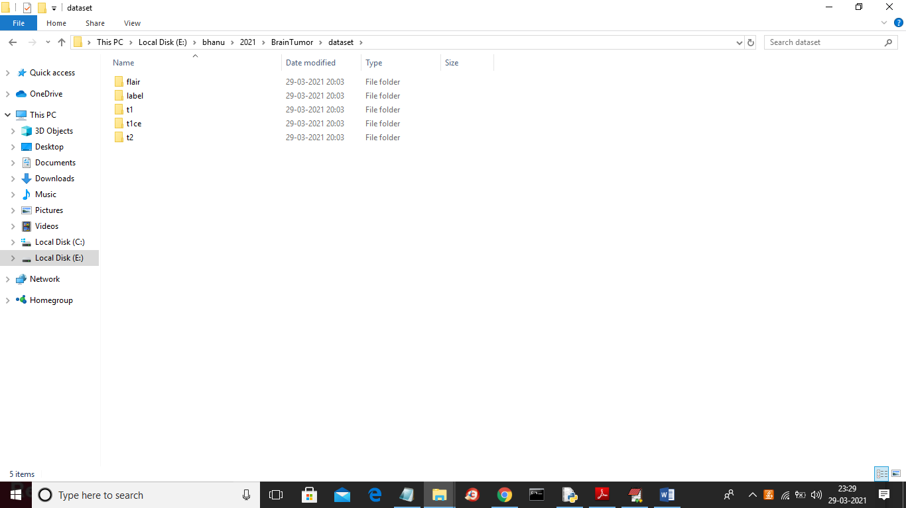

In above screen we have different format image and you can go inside any folder to see images

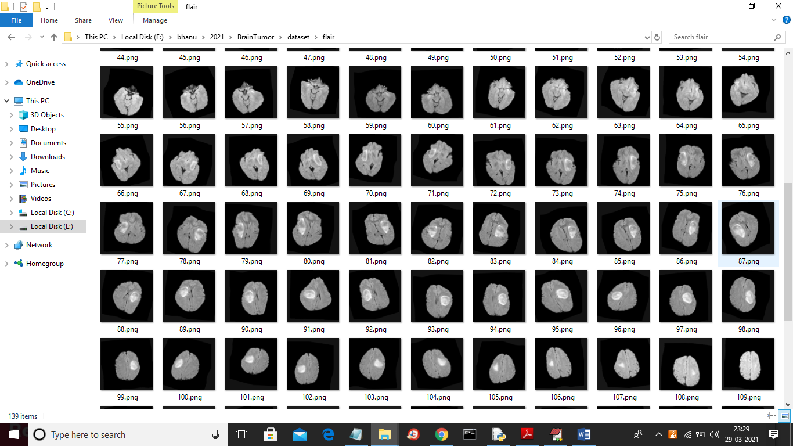

Above dataset is used to train CNN and UNET model

After building UNET and CNN model we will upload test images from ‘testSamples’ folder and then UNET model will give us segmented image. Below screen shots showing testSamples image

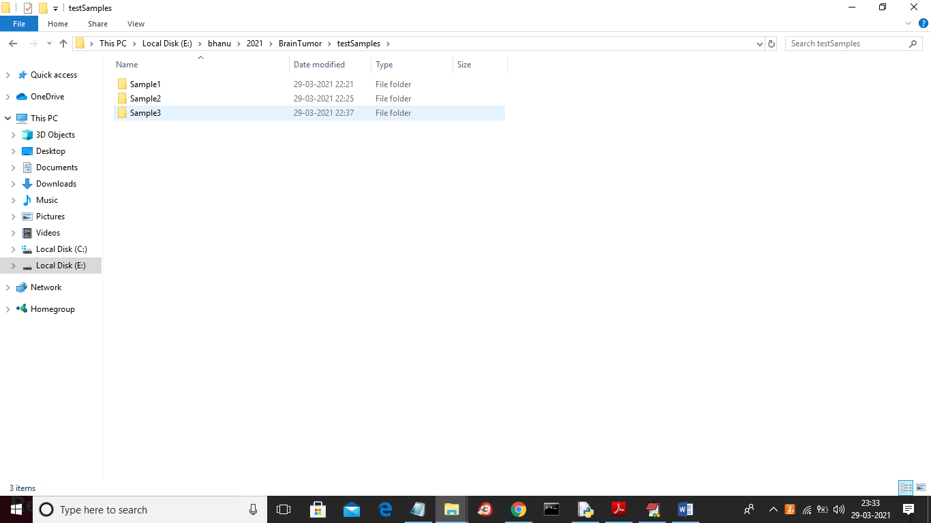

In above screen we have 3 samples images and now go inside any folder to get below images

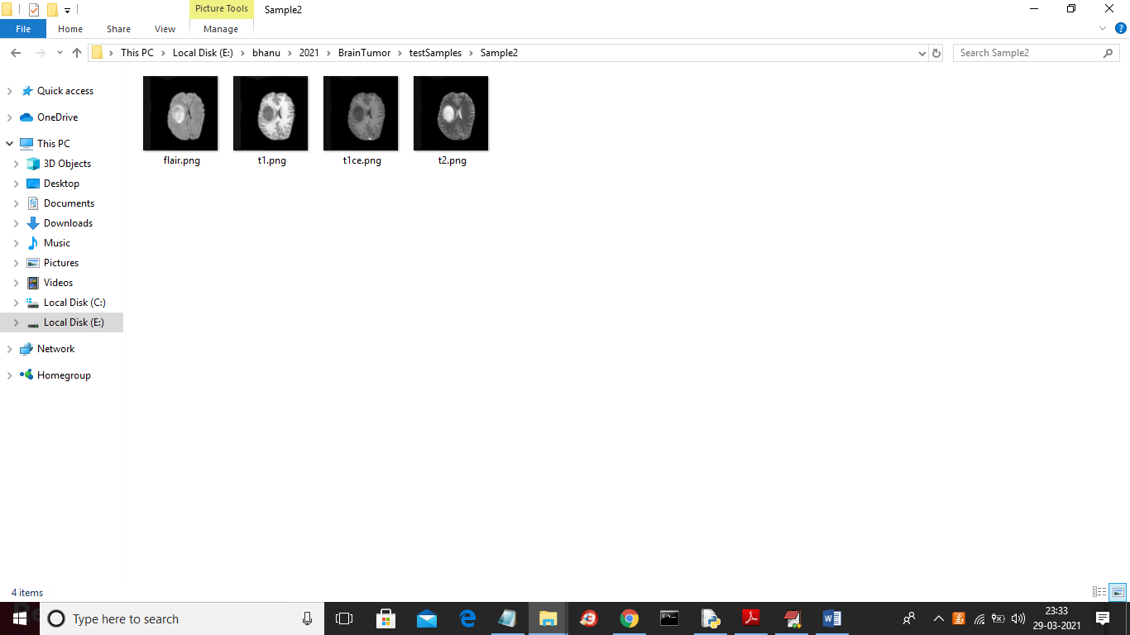

In above screen we have FLAIR, T1, TICE and T2 images but we don’t have segmented label image and after applying model on above images then we will get segmented label image.

To run project double click on ‘run.bat’ file to get below screen

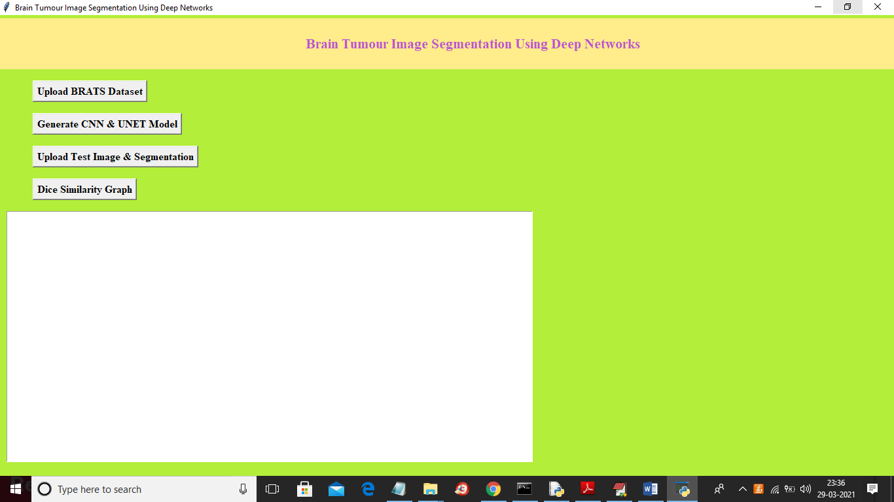

In above screen click on ‘Upload BRATS Dataset’ button to upload dataset

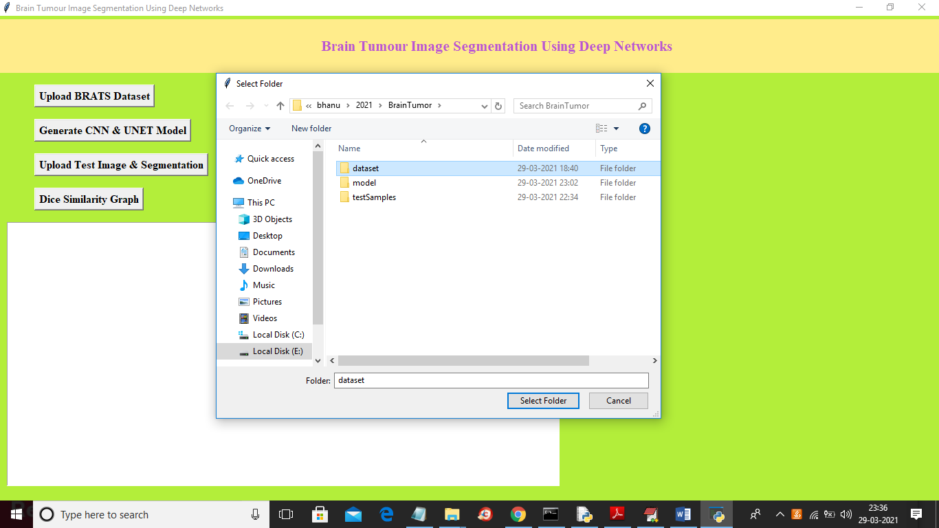

In above screen selecting and uploading ‘dataset’ folder and then click on ‘Select Folder’ button to load dataset and to get below screen

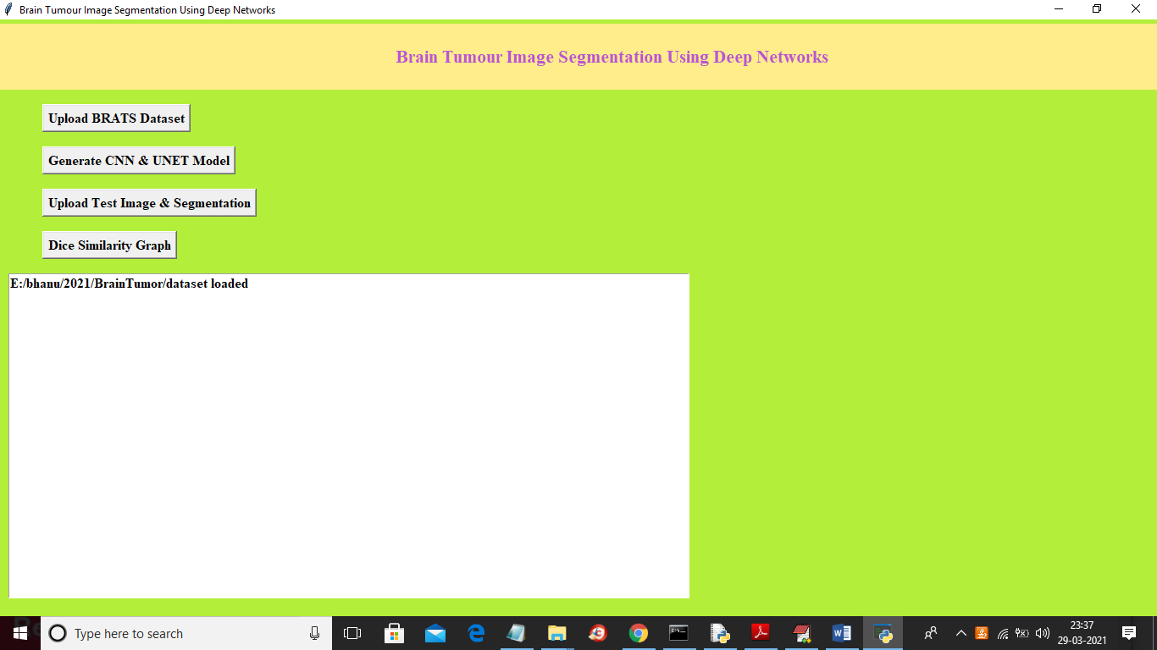

In above screen dataset loaded and now click on ‘Generate CNN & UNET Model’ button to generate models and to get below screen

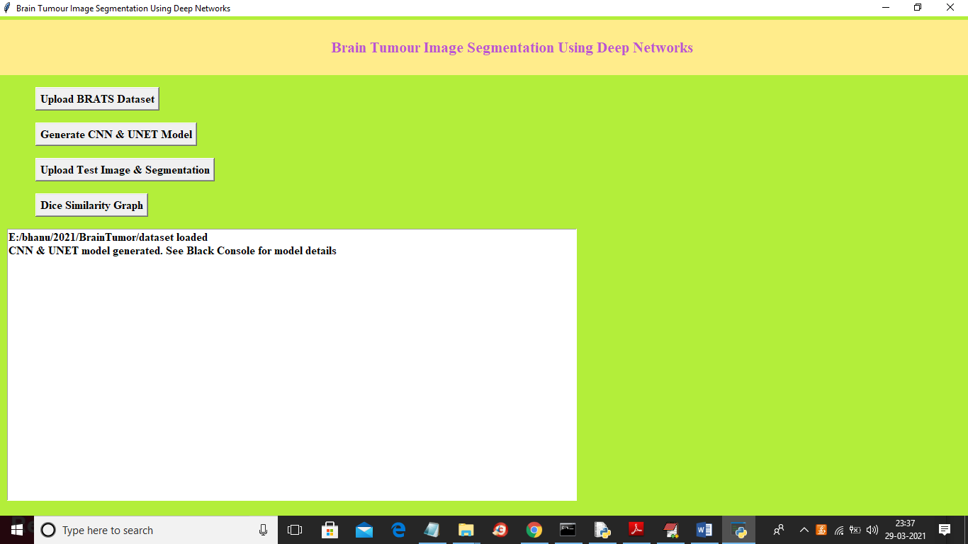

In above screen we can see both models are generated and we can see below black console to see CNN and UNET layer details

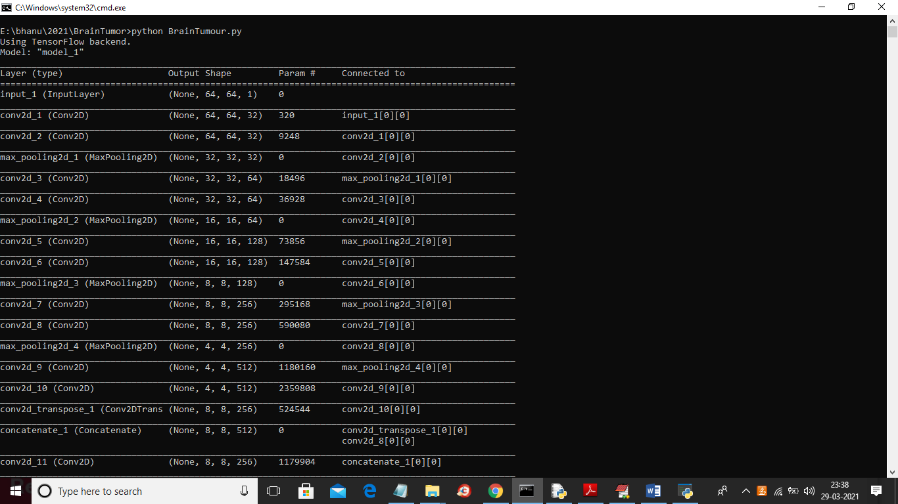

In above screen we can see models are using different size images to filter them and to get best features from it to build efficient model and now model is generate and now click on ‘Upload Test Image & Segmentation’ button and then upload test samples to get segmented output

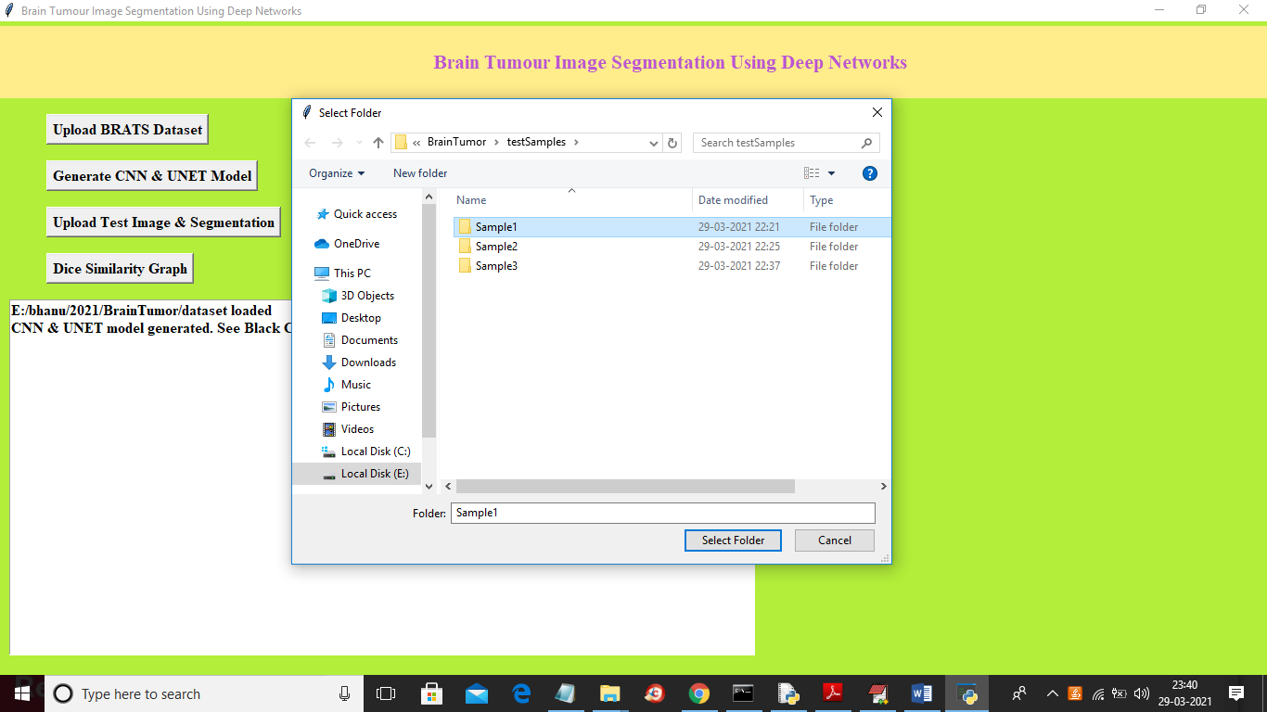

In above screen selecting and uploading ‘Sample1’ folder and then click on ‘Select Folder’ button to get below output

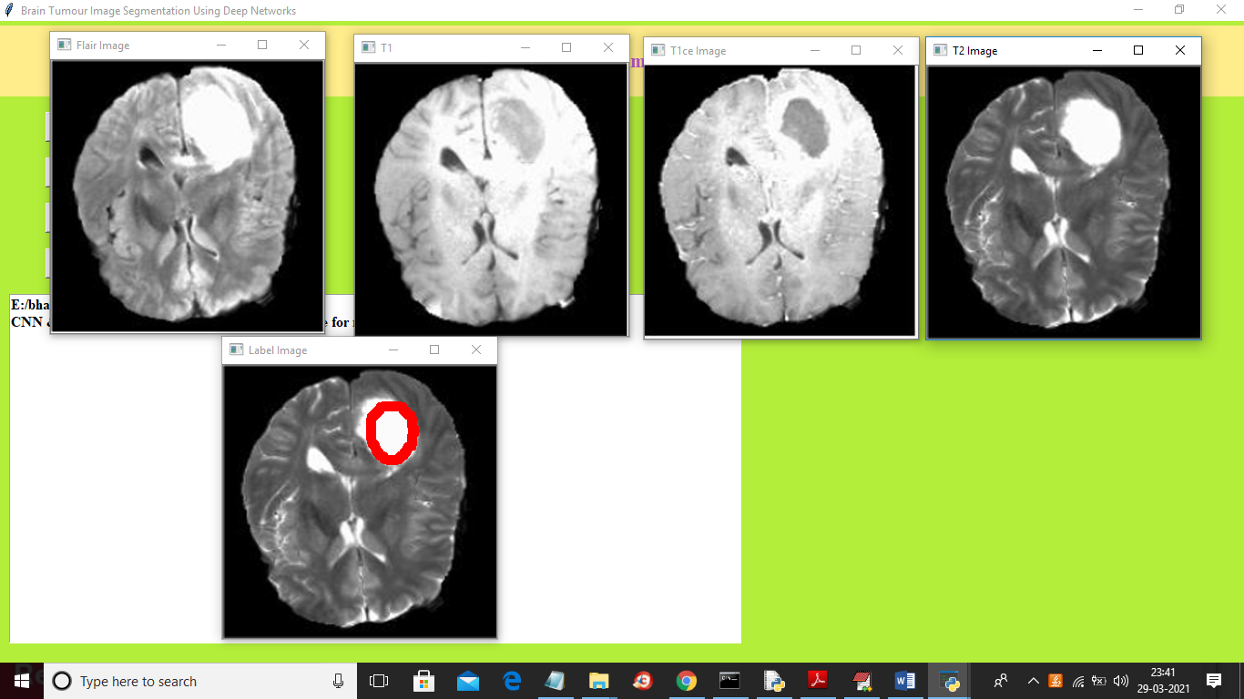

In above screen top 4 images are the input images such as FLAIR, T1, T2 and T1CE and 5th image is the predicted image with segmented part showing in red colour and this algorithm correctly detecting and marking tumour area and now test with other image

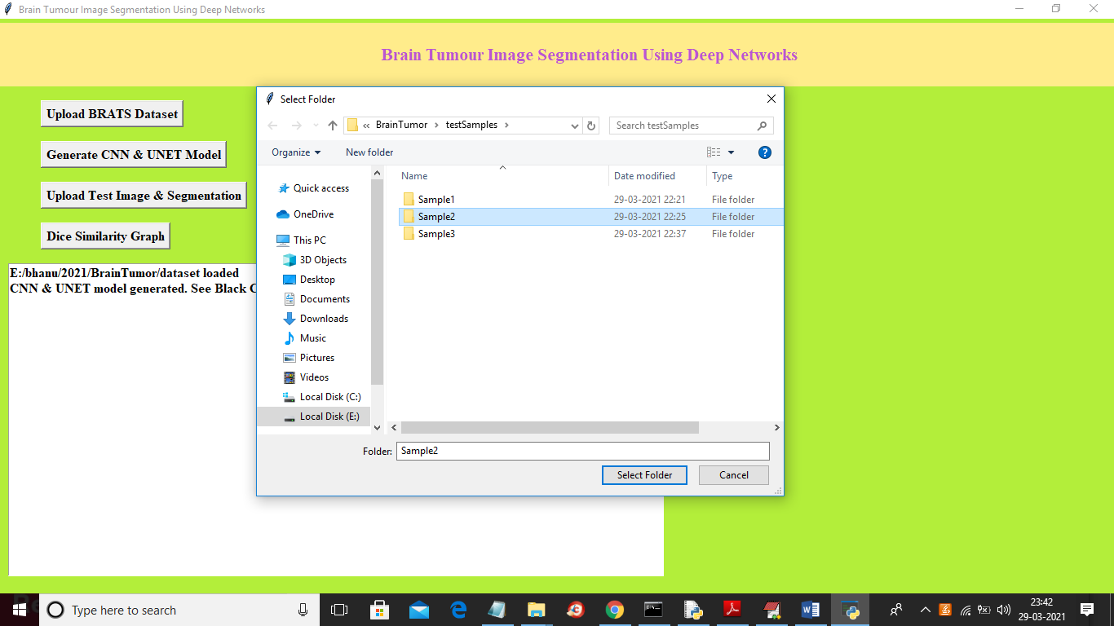

In above screen I am selecting and uploading ‘Sample2’ folder and then click on ‘Select Folder’ button to load images and to get below output

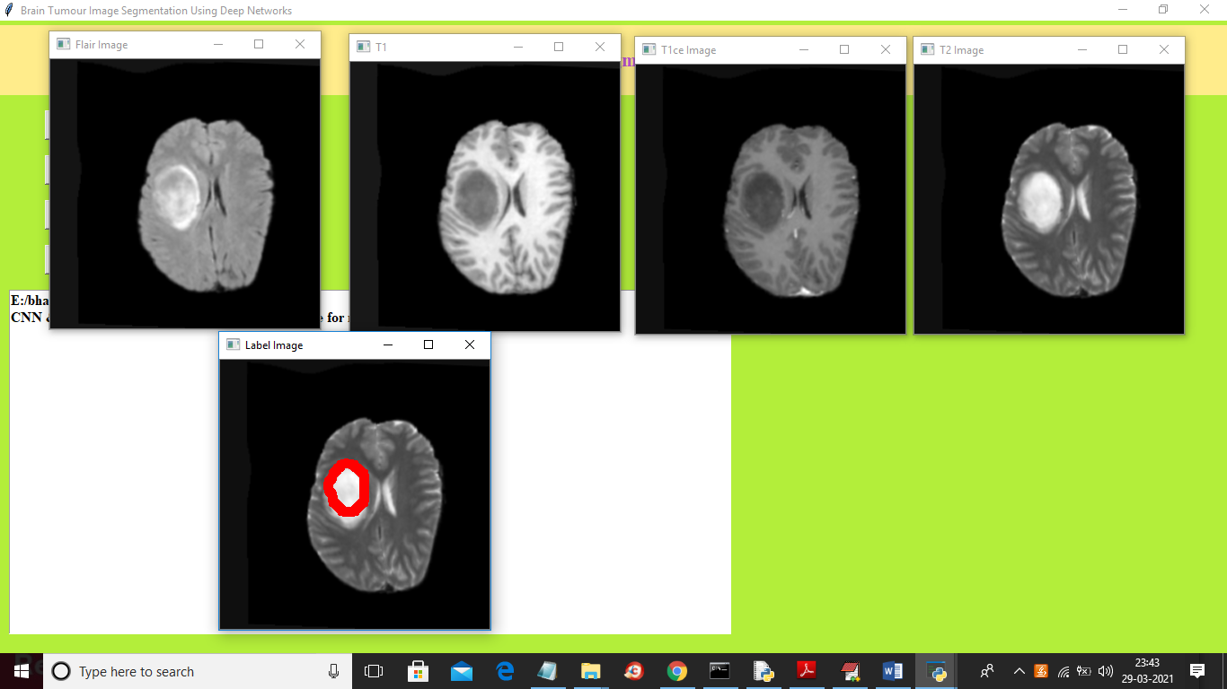

In above screen first 4 images are the input images and fifth image is the predicted label image with segmented parts around tumour area. Now click on ‘Dice Similarity Graph’ button to get below graph

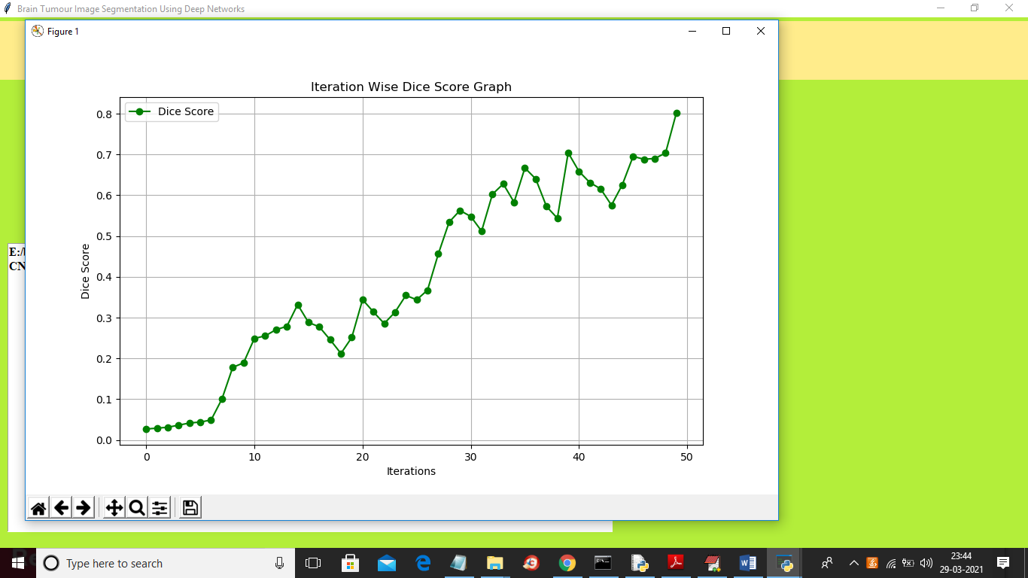

To build CNN and UNET model we took 50 epoch or iterations and at each iteration DICE score between training and testing images get better and better and we get final dice score as 0.8 * 100 = 80%. In above graph x-axis represents epoch and y-axis represents dice score

**8. CONCLUSION :**

In this work, we have described an ensemble of two networks, both of which are individually used frequently on the task of biomedical image segmentation. The ensemble successfully generates highly accurate segmentation of brain tumours from the multimodal MRI scans as provided by the BraTS 2019 challenge, which compares favourably with predictions given from various other state of the art models. We use a method of variable ensembling to combine the respective outputs from the model to achieve the best scores. The proposed ensemble offers an automated and objective method of generating brain tumour segmentation to aid in disease planning and patient management clinically.

**REFERENCES :**

[1] S. Bauer, R. Wiest, L. P. Nolte, and M. Reyes, “A survey of MRI-based medical image analysis for brain tumour studies,” 2013, [Online]. Available: http://www.

[2] R. Leece, J. Xu, Q. T. Ostrom, Y. Chen, C. Kruchko, and J. S. Barnholtz-Sloan, “Global incidence of malignant brain and other central nervous system tumours by histology, 2003--2007,” *Neuro. Oncol.*, vol. 19, no. 11, pp. 1553–1564, 2017.

[3] T. A. Dolecek, J. M. Propp, N. E. Stroup, and C. Kruchko, “CBTRUS statistical report: primary brain and central nervous system tumours diagnosed in the United States in 2005--2009,” *Neuro. Oncol.*, vol. 14, no. suppl_5, pp. v1--v49, 2012.

[4] D. N. Louis *et al.*, “The 2016 World Health Organization classification of tumours of the central nervous system: a summary,” *Acta Neuropathol.*, vol. 131, no. 6, pp. 803–820, 2016.

[5] R. Stupp *et al.*, “Radiotherapy plus concomitant and adjuvant temozolomide for glioblastoma,” *N. Engl. J. Med.*, vol. 352, no. 10, pp. 987–996, 2005.

[6] S. Bakas *et al.*, “Identifying the best machine learning algorithms for brain tumour segmentation, progression assessment, and overall survival prediction in the BRATS challenge,” *arXiv Prepr. arXiv1811.02629*, 2018.

[7] B. H. Menze, K. Van Leemput, D. Lashkari, M.-A. Weber, N. Ayache, and P. Golland, “A generative model for brain tumour segmentation in multimodal images,” in *International Conference on Medical Image Computing and Computer-Assisted Intervention*, 2010, pp. 151–159.

[8] S. Bakas *et al.*, “Advancing the cancer genome atlas glioma MRI collections with expert segmentation labels and radiomic features,” *Sci. data*, vol. 4, p. 170117, 2017.

[9] S. Bakas *et al.*, “Segmentation labels and radiomic features for the pre-operative scans of the TCGA-LGG collection,” *cancer imaging Arch.*, vol. 286, 2017.

[10] S. Bakas *et al.*, “Segmentation labels and radiomic features for the pre-operative scans of the TCGA-GBM collection. The Cancer Imaging Archive,” *Nat Sci Data*, vol. 4, p. 170117, 2017.